**filmreport Monsters inc.**

You are going to write a film report. The film you are going to watch is “Monsters inc”. Hand it in on paper! So you have to write it or print. Make sure it looks nice.

Task 1: Title

The first page of the report. You need:

-Picture

-Your name and class

-Title

Task 2: Information

**General**

1. Title

2. Name of the director.

3. The year

**Title**

- What does the title mean?

**Beginning**

- What is the beginning of the story? You can choose between:

a. an Introduction

b. In an event

c. At the end of an event.

Explain your choise.

**End**

- Explain the end of the film.

**Location**

- Where is the film set?

Task 3: Content

- Write a summery. Use at least 7 sentences.

Task 4: Film cast

**Characters**

- Write the correct name of the character.

- Who are the main characters (Draw a star)

- Describe the characters.

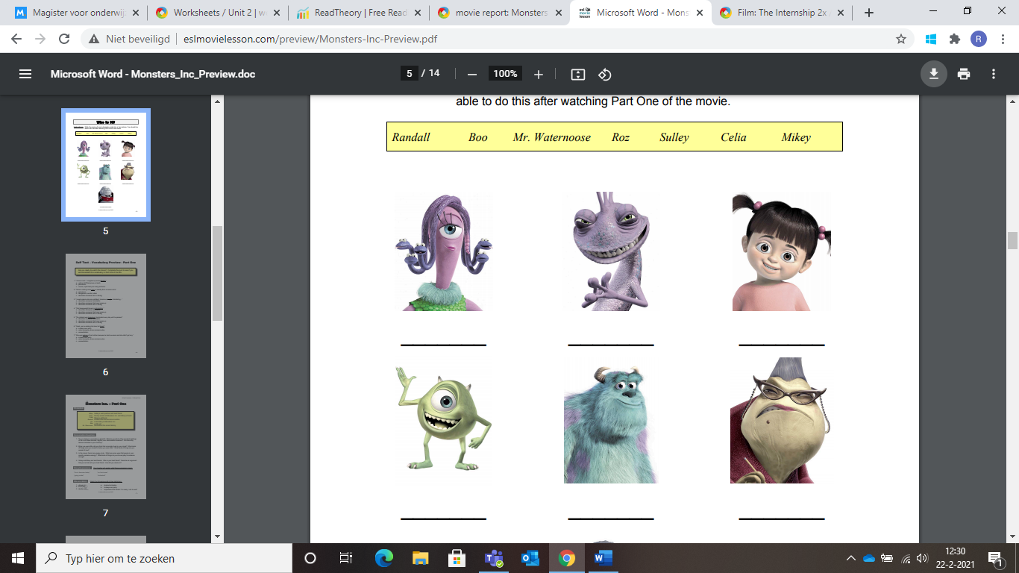

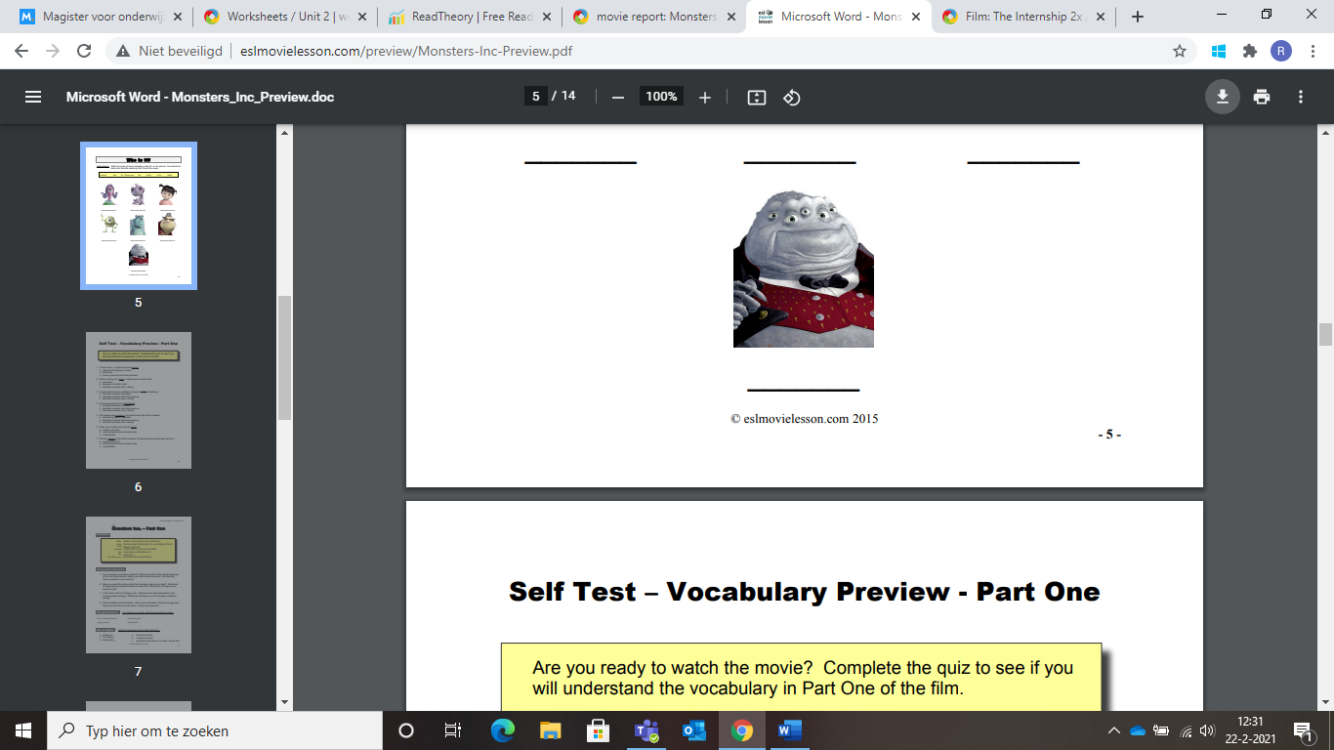

Task 5: Vocab

What is the correct meaning of these words. (Have a look on the internet if you don’t know the answer)

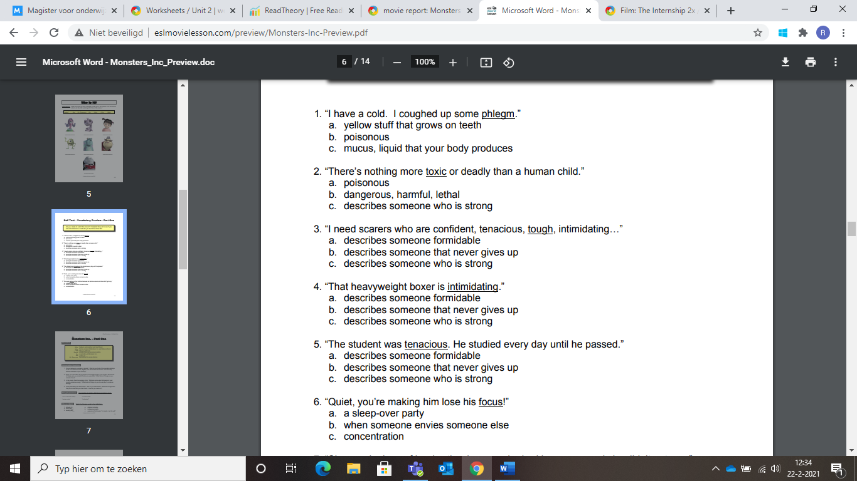

Task 6: Your opninion

- What do you think of this film? (Use at least 5 words)

- The person you like best and why.

- What scene was most exciting and why.