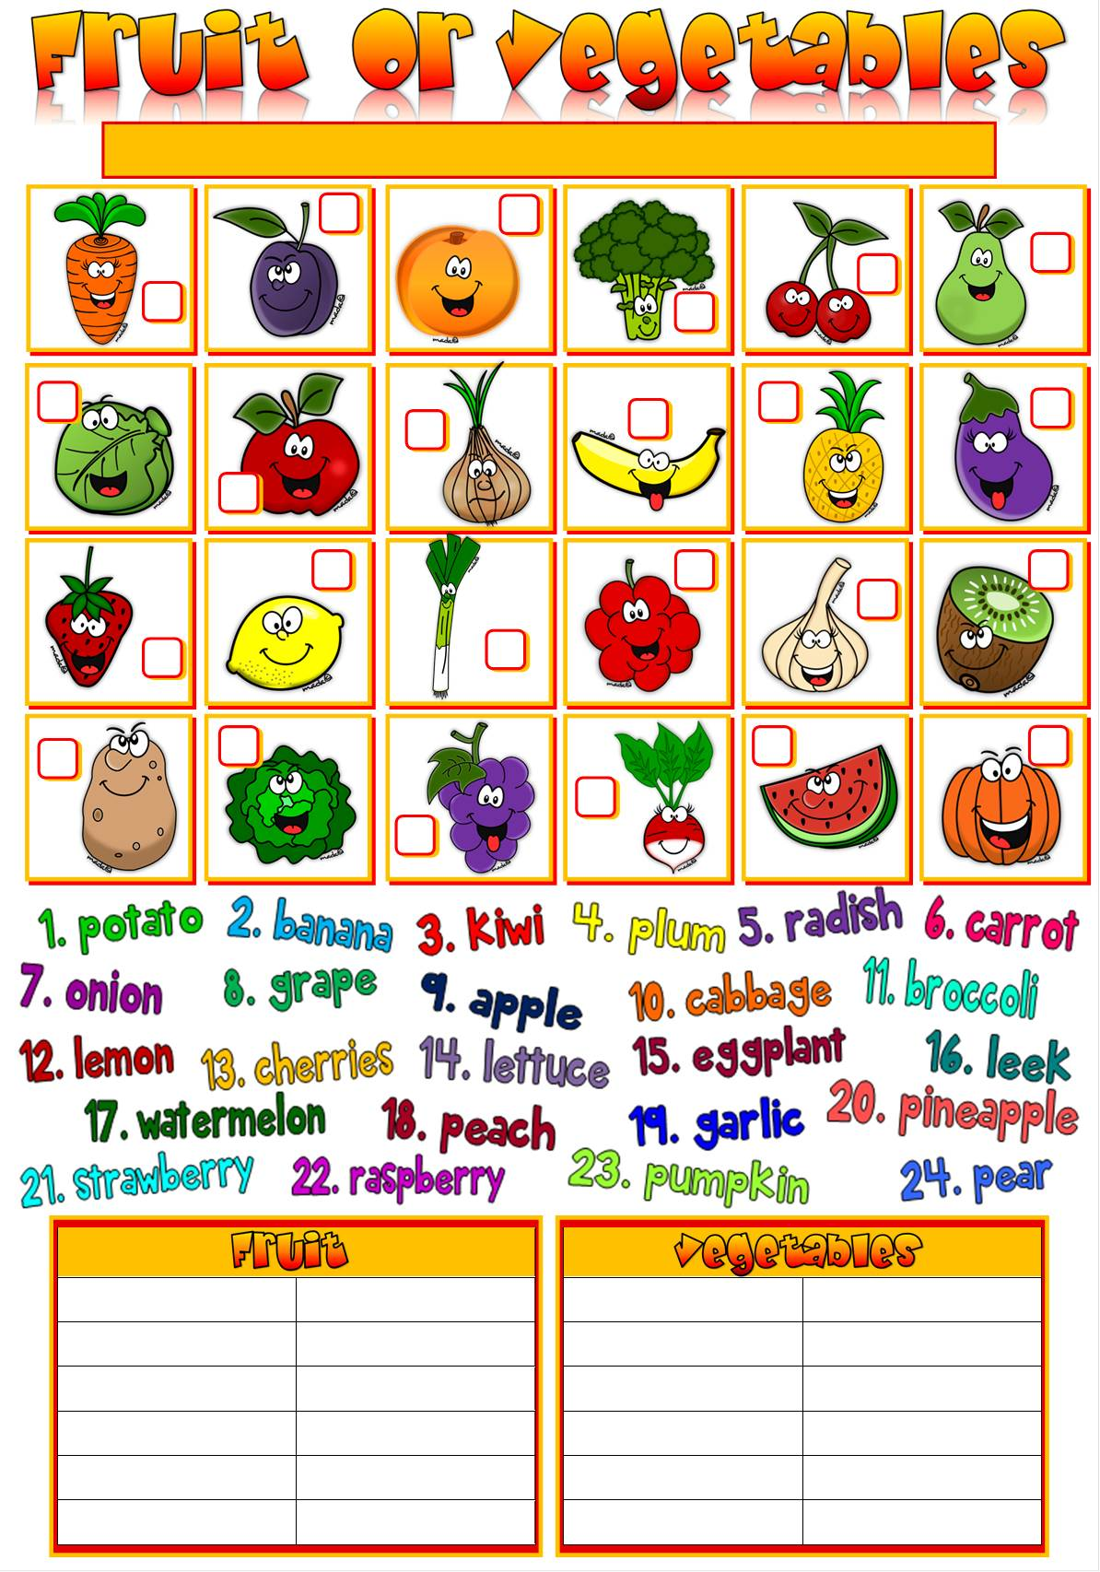
Label the pictures. Then put the words in the correct column in the table below.

