Match words and pictures
1

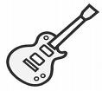
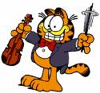
bed
2

3

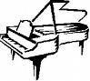
chair

cupboard

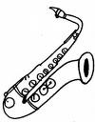
drawer
4

5

6

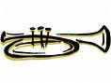
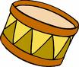
drum

fridge
10

guitar
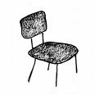
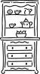
7

8

9

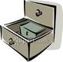
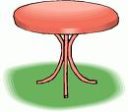
piano

saxophone

sofa
11

13

12

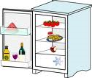
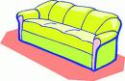
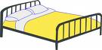
table

trumpet

violin
1

Write the words (more than 1 answer possible)

- You sleep in this : ……………………………………………………………
- You blow on this : ……………………………………………………………
- You put milk in this : ……………………………………………………………
- You have this in the kitchen : ……………………………………………………………

