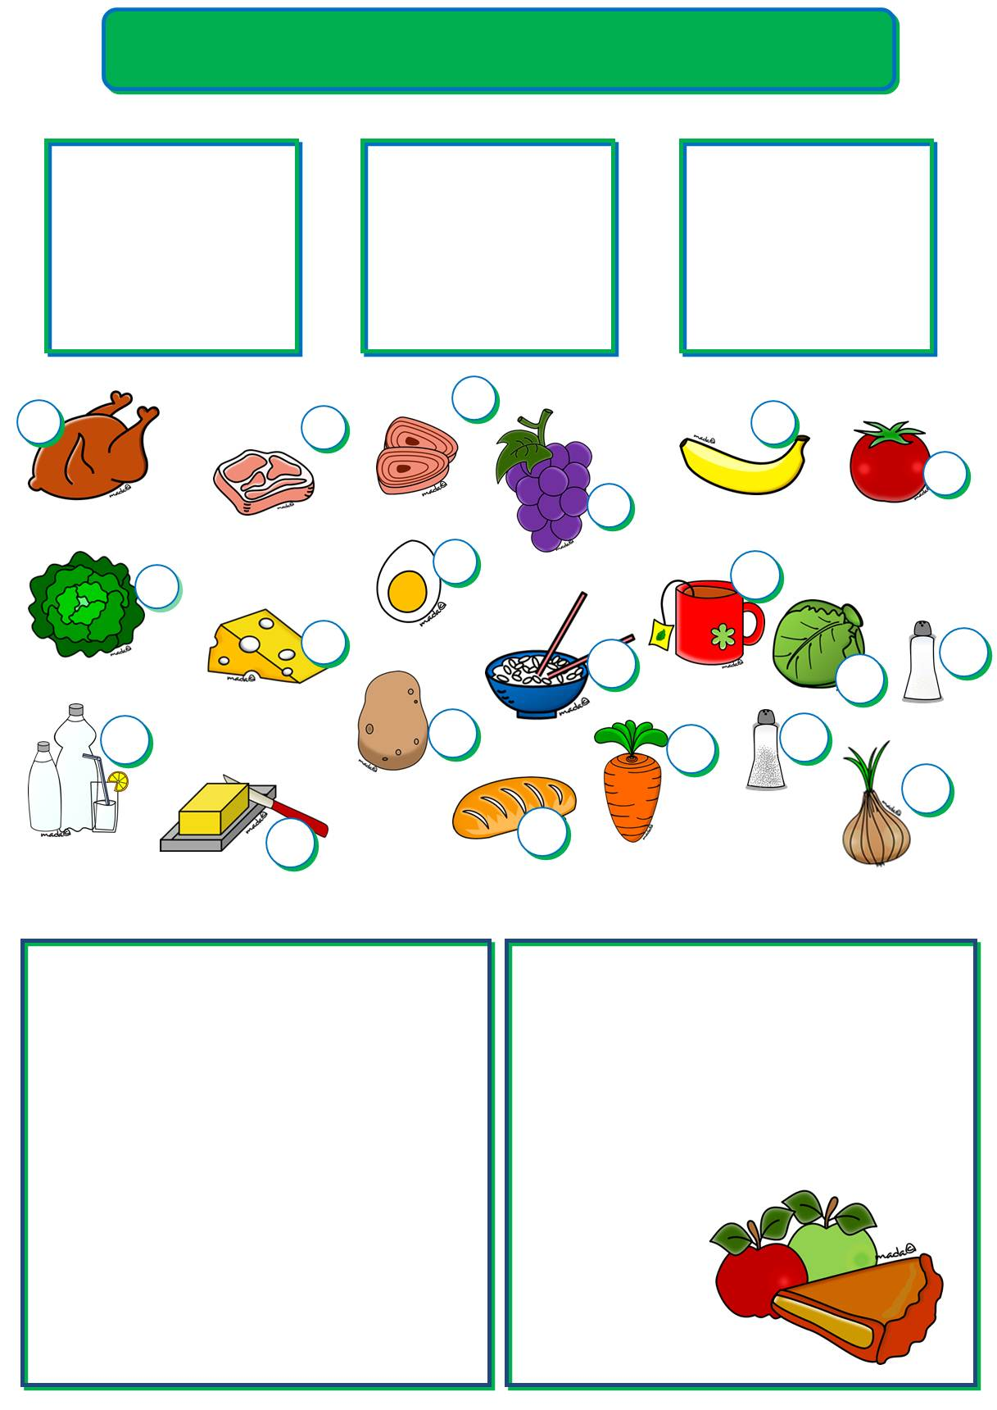
Name:Signed:
Score: /84Mark:

1. Write C for countable and U for uncountable. (15 marks)

- sugar ____
- pencil ____
- biscuit ____
- rice ____
- cup ____
- flower ____
- jam ____
- juice ____
- slice ____
- paper ____
- tiger ____
- bread ____
- butter ____
- plate ____
- chair ____

3
2. Label the pictures. (20 marks)
_ _ _ _e_
_o_ _ _ _
2
1
5
_o_ _
6
4
_ _ i _ _ _ _
_a_ _ _ _
_ _ _a
7
9
11
_ _ _ e_ _

_ i _ _
_a_ _a_ _

13
8
10
12
e_ _
_ _ _ _ _ _e
_e_
19
14
16
18
_ _ _ _e_
_a_ _
_ _ _a_
20
_o_ _ _ _
15
17
_e_ _e_
_a_ _ _
_ _ _ _o_
_ _ i _ _
3. Read the dialogue and circle the correct words. (16 marks)
Lucy How about making ¹ a / an apple pie?
Alan Great idea! Have we got ² some / any
apples?
Lucy Yes, there are ³ some / any in the
bowl. How ⁴ much / many do we need?
Alan A lot, about a ⁵ kilo / litre.
Lucy We haven’t got enough. We can buy ⁶ some / any in the corner shop.
Alan And we need ⁷ some / any flour, too. Look at the recipe. How ⁸ much / many flour do we need?
Lucy About half a pound. And we need three ⁹ knives / spoons of sour cream so let’s
buy a small ¹⁰ tub / bag, too.
Alan And how ¹¹ much / many eggs do we need?
Sue Four. And we also need ¹² some / any butter and ¹³ some / any sugar. Oh, we haven’t got ¹⁴ some / any butter.
Andy We can buy a ¹⁵ bar / tin of butter in the shop, too.

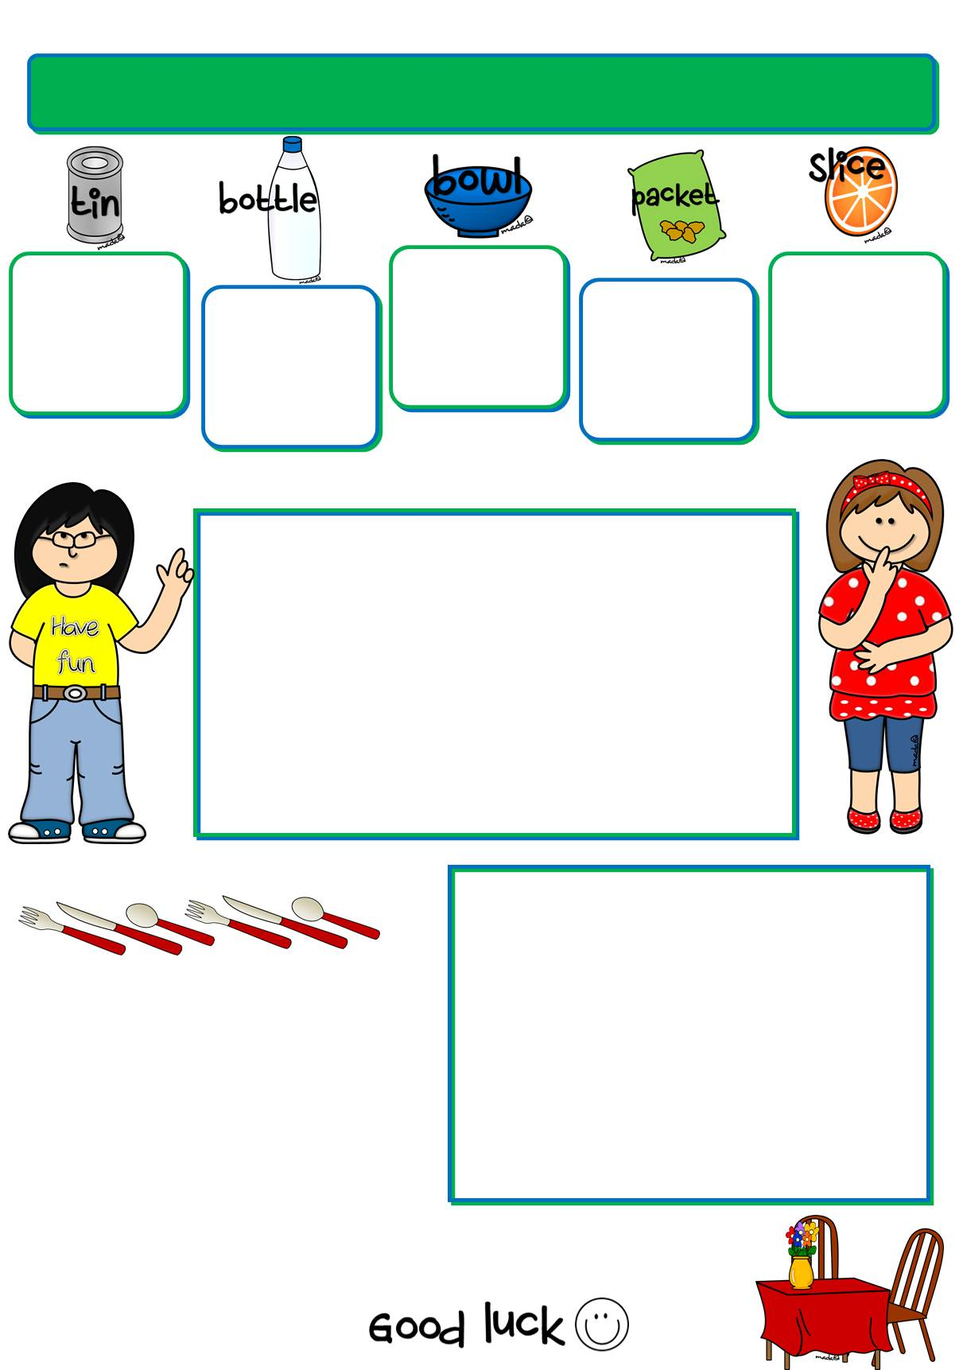
biscuits bread cereal crisps dog food fried tomatoes ham lemon oil salad sardines soup sugar water wine
4. Put the words in the box in the correct group. (15 marks)

____________________________________
____________________________________
____________________________________
____________________________________
____________________________________

5. Circle the odd one out. (10 marks)

- bowl plate glass knife
- beef trout lamb pork
- lettuce carrots bananas mushrooms
- buy market shop supermarket
- cup carton bar bottle
- some many any a
- sandwich juice milk lemonade
- lemon water fork egg
- onion apple orange bean
- tuna cola grape pasta

6. Order the dialogue. (8 marks)
Waiter_________________________________________
Tom _________________________________________
Waiter_________________________________________
Tom _________________________________________
Waiter_________________________________________
Tom _________________________________________
Waiter_________________________________________
Tom _________________________________________

- Just a bottle of mineral water, please.
- Are you ready to order?
- Would you like a dessert?
- Yes, can I have some mixed vegetables, please?
- No, thank you. That’ll be all.
- Anything else?
- Certainly. Do you want something to drink?
- Yes, I’d like chicken with rice, please.

