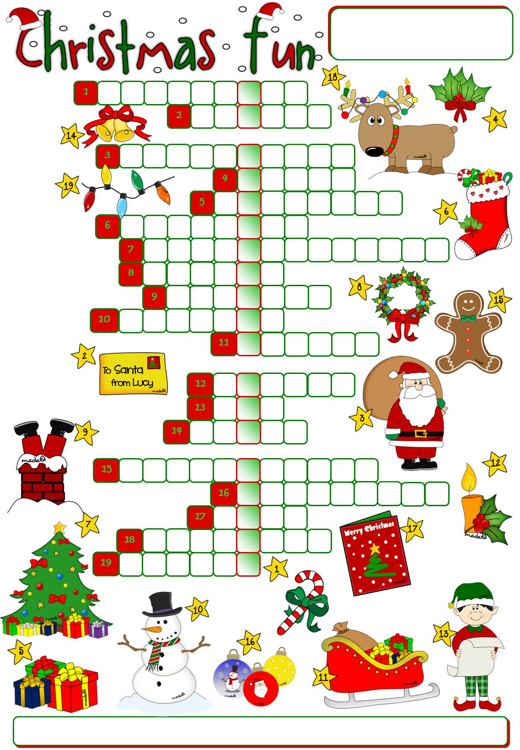
bells
candle
candy cane
card
chimney
Christmas tree
elf
gingerbread
holly
letter
lights
ornaments
presents
reindeer
Santa Claus
sleigh
snowman
stocking
wreath

Match the words to the correct pictures to complete the crossword. Then find a secret message.

The secret message is _________ __________________ _________ ______________ lead home.

