Match the pictures and the words.
SHAMROCK

IRISH TOP HAT

HARP
BEER
POT OF GOLD
POT OF SHAMROCKS
ST PATRICK’S DAY HAT
RAINBOW
HORSESHOE
CROSS
COINS
LEPRECHAUN
1
2
3
4
5
6
7
8
9
10
11
12
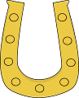
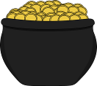

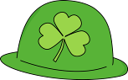
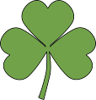
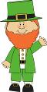
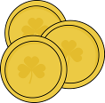

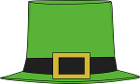



12
SHAMROCK

IRISH TOP HAT

HARP

BEER

POT OF GOLD

POT OF SHAMROCKS

ST PATRICK’S DAY HAT

RAINBOW

HORSESHOE

CROSS

COINS

LEPRECHAUN

4
2
8
6
11
3
7
9
5
1
10

