**FAMILY MEMBERS**

1. 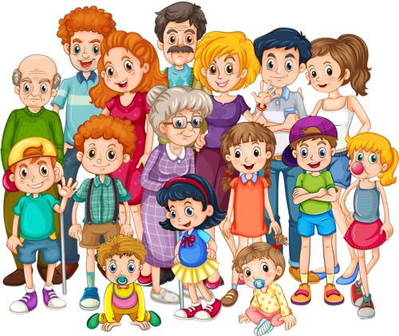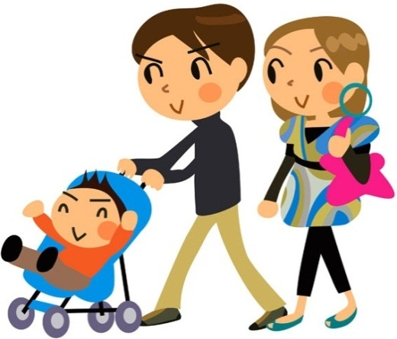***Do the crossword.*** 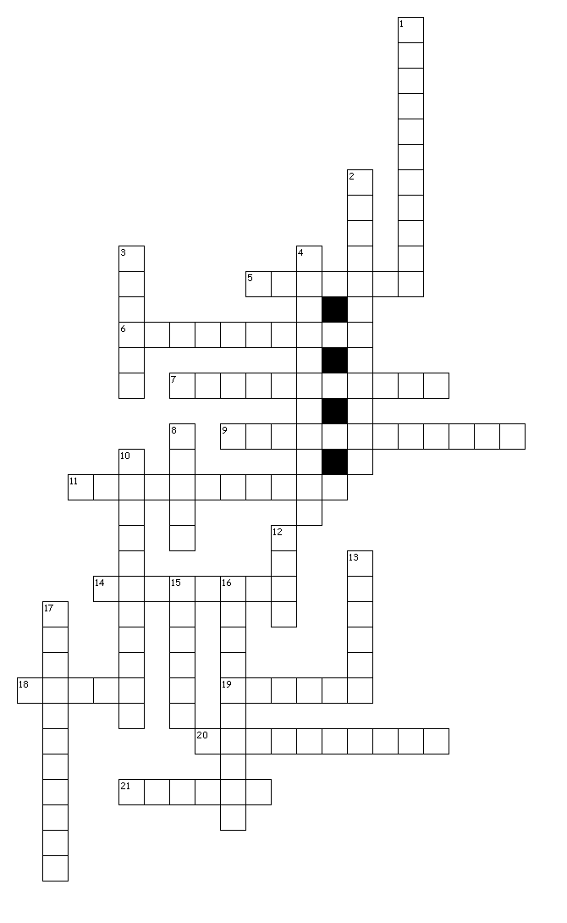

**ACROSS**

5. Your mother's son

6. Your mother's new husband (not your father)

7. Your boyfriend's sister

9. Your son's daughter

11. Your boyfriend's father

14. Your daughter's son

18. Your father's brother

19. Your father's wife

20. Your stepmother's daughter

21. Your father's daughter

**DOWN**

1. Your mother's father

2. Your boyfriend's brother

3. Your aunt's son/daughter

4. Your boyfriend's mother

8. Your sister's daughter

10. Your stepfather's son

12. Your father's sister

13. Your mother's husband

15. Your brother's son

16. Your father's new wife (not your mother)

17. Your father’s mother