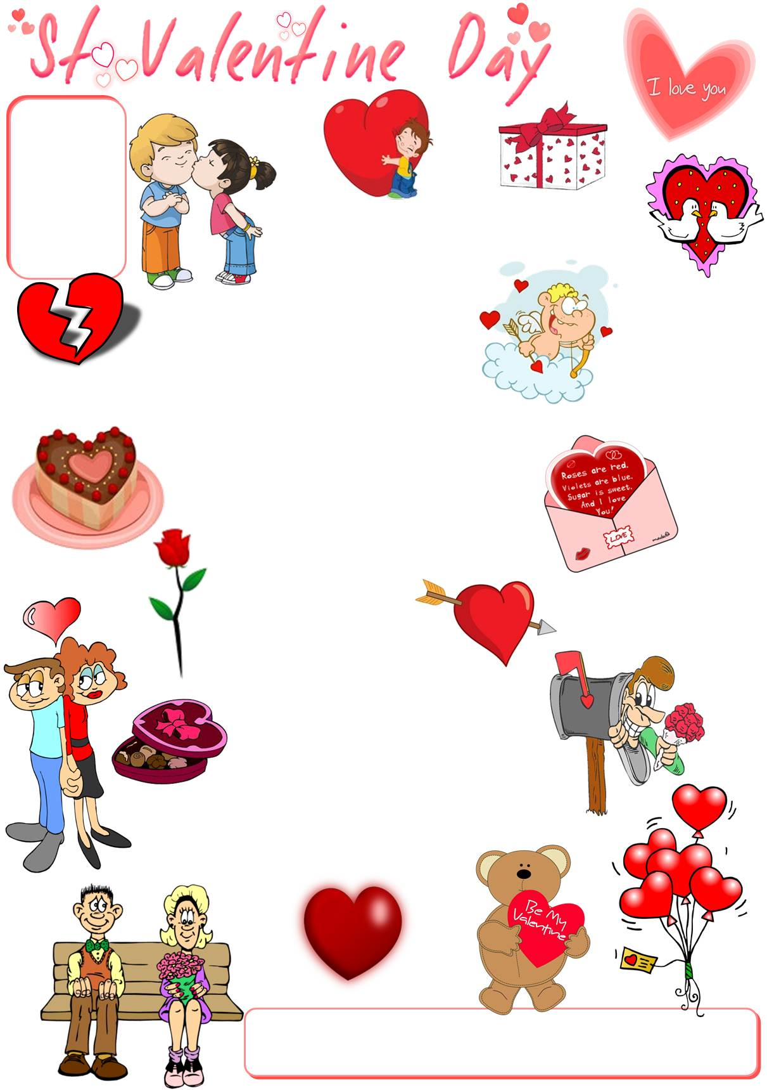
10
Match the words to the correct pictures and complete the crossword. Then find a secret message.

The secret message is Anyone can catch your eye, ________ ________ ___________ ____________ special to catch your heart.
__________ __________ __________ __________ __________ __________ .

1
2
3
4
5
6
7
9
11
arrow
balloons
broken heart
cake
chocolate
Cupid
date
doves
flowers
gift
heart
hug
kiss
love
poem
rose
teddy

12
13
14
15
16
17
8
2
1
3
4
5
6
7
8
9
10
11
13
14
15
16
17
12

10
Match the words to the correct pictures and complete the crossword. Then find a secret message.

1
2
3
4
5
6
7
9
11
12
13
14
15
16
17
8

