Reading

You are going to read a text. Answer the questions on paper.

**The Channel Tunnel:**

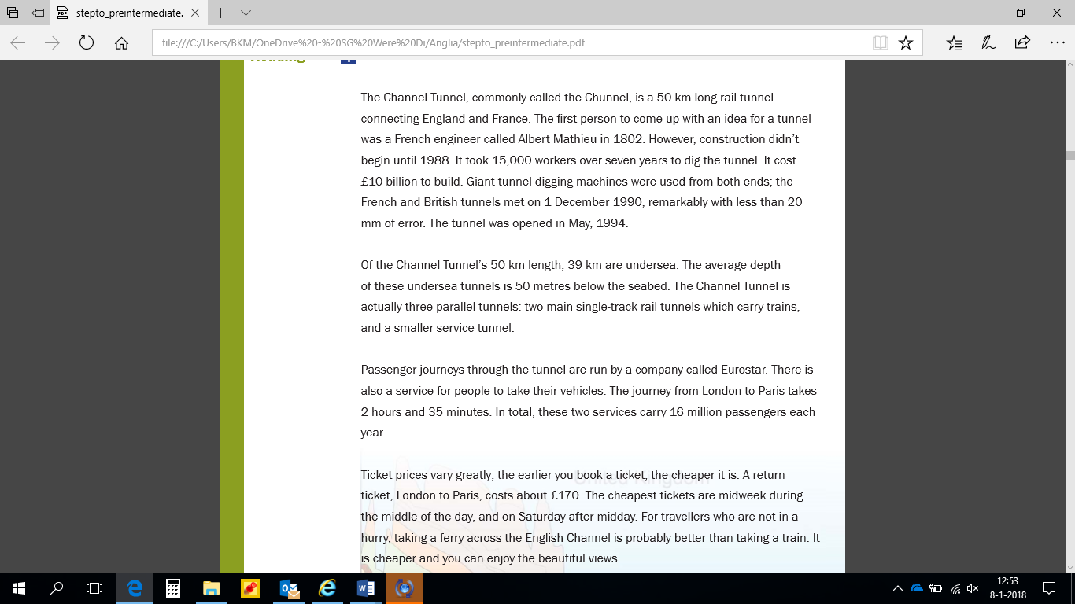

**Answer the questions:**

1. How long did it take to dig the Channel Tunnel?

2. What is the total length of the tunnel?

3. Why would some people rather take the ferry across the English Channel?

1

2

4. The French began building the Channel Tunnel in 1802.

True/ False

5. The average depth of the tunnel is 50 metres below sea level.

True/ False

6. The Channel Tunnel consists of…

A. a single tunnel.

B. two tunnels.

C. two main tunnels and a smaller service tunnel.

7. How long does the train trip between the English and French capital cities take?

A. Just over two hours.

B. Just over two and a half hours.

C. A little less than three hours.

8. Which of the following times would be best for getting a cheap train ticket?

A. 2.00pm on Wednesday.

B. 8.00am on Saturday.

C. Noon on Sunday.

9. Find the word in the passage which means the OPPOSITE of: above (paragraph 2)

10. Find the word in the passage which means the SAME as: rush (paragraph 4)