 |  |  |  |  |  |  |  |  |  |  |  |  |  |  |  | 
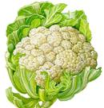  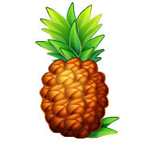                            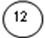  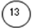  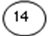  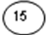  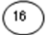  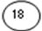  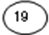  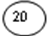  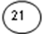  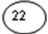  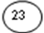  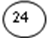  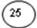  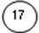  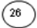 |  |  |  | Look at the pictures and indentify the food items by filling in the crossword
 |  |  |  |  |  |  |  |  |  |  |  |  |  |  |  |  |  |  |  |  |  |  |  |  |  |  |  |  |  |  |  | 
 |  |  |  |  |  |  |  |  | 1 |  |  |  |  |  |  |  |  |  |  |  |  |  |  |  | 2 |  |  |  |  |  |  |  |  |  | 24
 |  |  |  |  |  |  |  |  |  |  |  |  |  |  |  |  |  |  |  |  |  |  | 3
 |  |  | 4
 |  |  |  |  |  |  |  |  |  |  |  |  |  |  | 5 |  |  |  |  |  | 18
 |  |  |  |  | 6
 |  |  |  |  |  |  |  |  |  |  |  |  |  |  |  |  |  |  |  |  |  |  | 7 |  |  |  |  |  |  |  |  |  |  |  |  |  | 9
 |  |  |  |  |  |  | 10 |  |  |  | 11 |  |  |  |  |  |  |  |  |  |  |  |  |  |  |  |  |  |  |  | 12
13 |  |  |  |  |  |  |  |  |  |  |  |  |  |  |  |  |  |  |  |  |  |  |  |  |  |  | 14 |  |  |  |  |  |  |  | 8 |  |  |  |  |  | 25
 |  |  |  |  |  |  |  |  |  |  |  |  |  |  |  |  |  |  |  |  |  |  |  |  |  |  |  |  | 15
 |  |  |  |  |  |  |  |  |  |  |  |  | 16
 |  |  |  |  | 17 |  |  |  |  |  |  |  |  |  |  |  |  |  | 20
 |  |  |  |  |  |  | 22 |  |  |  |  |  |  |  |  |  | 19
 |  |  |  |  | 23
 |  |  |  |  |  |  |  |  | 26
 |  |  |  |  |  |  |  |  |  |  |  |  |  |  |  |  |  |  |  |  |  |  |  |  |  |  |  |  |  |  | 21

